

# Welcome on Board!

Dear learners,

Welcome to this MOOC entitled “Spice up Your English”.

The objective of this MOOC is to help you learn English. Learning a language can be compared to cooking. Indeed, you need good ingredients and spices but you also need a clear recipe to know how to combine all these ingredients and create a delicious meal.

In this MOOC, you are going to receive some basic ingredients to learn English: a bit of vocabulary, some grammar bites and portions of pronunciation. You will also learn how to do things in English; in other words, you will learn skills. The last important element is of course your participation. You will be able to add your pinch of salt and personalize your learning, adapt it to your needs in order to become successful learners.

This notebook will help you succeed in this cooking adventure because it contains essential content related to each module, tips and strategies about learning and serves as an everyday guide. Make it personal and your daily companion. I hope you will find it useful.

Enjoy!





 October 2016 

This working calendar will help you plan your work and keep track of all the important deadlines in the MOOC.

|  |  |  |  |  |  |  |
| --- | --- | --- | --- | --- | --- | --- |
| Sunday | Monday | Tuesday | Wednesday | Thursday | Friday | Saturday |
|  |  |  |  |  |  | 1 |
|  |  |  |  |  |  |  |
| 2 | M0 3 | 4 | 5 | 6 | 7 | 8 |
|  |  |  | World Teachers’ Day |  |  |  |
| 9 | M1 10 | 11 | 12 | 13 | 14 | 15 |
|  |  |  |  |  |  |  |
| 16 | M2 17 | 18 | 19 | 20 | 21 | 22 |
|  |  |  |  |  |  |  |
| 23 | M3 24 | 25 | 26 | 27 | 28 | 29 |
|  |  |  |  |  |  |  |
| 30 | M4 31 |  |  |  |  |  |
|  |  |  |  |  |  |  |

Tips of the Month:

* Set clear objectives since the beginning (max.3).
* Immerse yourself in the language.
* You need more than a course, a book or a teacher to learn a language.
* Choose the way of learning that suits you best.



 November 2016 

|  |  |  |  |  |  |  |
| --- | --- | --- | --- | --- | --- | --- |
| Sunday | Monday | Tuesday | Wednesday | Thursday | Friday | Saturday |
|  |  | 1 | 2 | 3 | 4 | 5 |
|  |  |  |  |  |  |  |
| 6 | M5 7 | 8 | 9 | 10 | 11 | 12 |
|  |  |  |  |  |  |  |
| 13 | M6 14 | 15 | 16 | 17 | 18 | 19 |
|  |  |  |  |  |  |  |
| 20 | M7 21 | 22 | 23 | 24 | 25 | 26 |
|  |  |  |  |  |  |  |
| 27 | M8 28 | 29 | 30 |  |  |  |
|  | Final Evaluation: START |  |  |  |  |  |
|  |  |  |  |  |  |  |
|  |  |  |  |  |  |  |

Tips of the Month:

* Always learn vocabulary in context.
* Revise what you have learned regularly; “ a little but often.”
* A language is more than just learning grammar and vocabulary.
* Seize every opportunity to practice the language.



December 2017 

|  |  |  |  |  |  |  |
| --- | --- | --- | --- | --- | --- | --- |
| Sunday | Monday | Tuesday | Wednesday | Thursday | Friday | Saturday |
|  |  |  |  | 1 | 2 | 3 |
|  |  |  |  |  |  |  |
| 4 | M9 5 | 6 | 7 | 8 | 9 | 10 |
|  | Last module |  |  |  |  |  |
| 11 | 12 | 13 | 14 | 15 | 16 | 17 |
|  | End registrations |  |  |  |  |  |
| 18 | 19 | 20 | 21 | 22 | 23 | 24 |
|  |  |  |  |  |  |  |
| 25 | 26 | 27 | 28 | 29 | 30 |  |
| Merry Christmas | Day off | Day off | Day off | Day off | Day off |  |
|  |  |  |  |  |  |  |

Tips of the Month:

* Don’t be afraid of mistakes!
* You need a lot of practice just like when you learn a sport or how to cook.
* The muscles in your mouth and jaws have to hurt when you practice pronunciation.
* Try to interact with other people!



 January 2017 

|  |  |  |  |  |  |  |
| --- | --- | --- | --- | --- | --- | --- |
| Sunday | Monday | Tuesday | Wednesday | Thursday | Friday | Saturday |
|  |  |  |  |  |  |  |
|  |  |  |  |  |  |  |
| 1 | 2 | 3 | 4 | 5 | 6 | 7 |
| Happy New Year |  |  |  |  |  |  |
| 8 | 9 | 10 | 11 | 12 | 13 | 14 |
|  |  |  |  |  |  |  |
| 15 | 16 | 17 | 18 | 19 | 20 | 21 |
|  |  |  |  |  |  |  |
| 22 | 23 | 24 | 25 | 26 | 27 | 28 |
|  |  |  |  |  |  |  |
| 29 | 30 | 31 |  |  |  |  |
|  | Final evaluation: END |  |  |  |  |  |

Tips of the Month:

* Learning a language is a lifelong process.
* You need to continue to practice the language.
* Feel confident!
* Keep an open mind!

# Module 1: Slices of Language

* On the Menu: 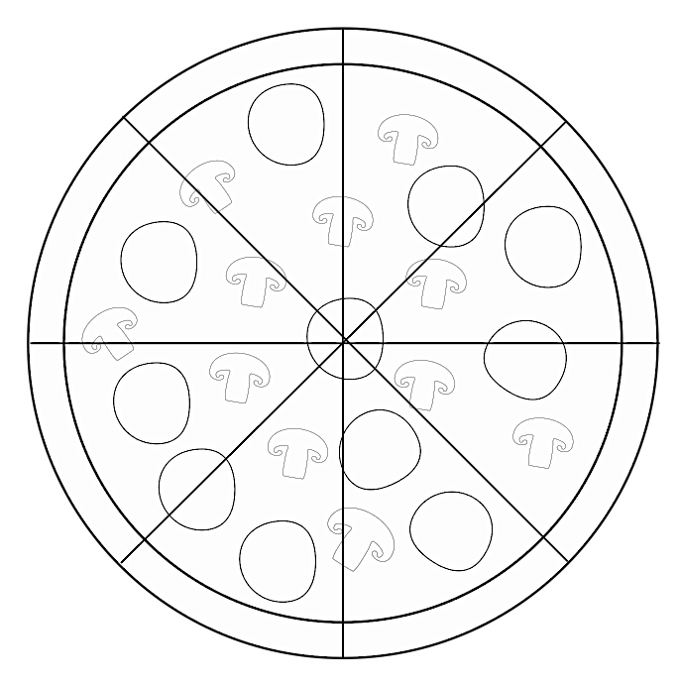

1. To learn what a language is
2. To learn the differences between English and French
3. To learn tips about learning a language
4. To find your learning style
5. To fill in your learner profile

## What is a Language?

We all speak a language that helps us to communicate and express the reality around us. There is not a unique way of seeing reality. A language is then one way of viewing reality. Each time you learn a new language, you learn a new way of looking at the world. It is not always easy because you have reflexes in your own mother tongue and a certain way of thinking. It is important to forget your approach to the world and to be open-minded. You have to accept that this new language sees and expresses reality differently. Knowing more than one language is a real asset in life because it helps you be open-minded.

## English vs. French

English and French have a lot in common because they share the same roots and origins. However, there are also differences between these languages. Here are some examples:

|  |  |  |
| --- | --- | --- |
|  | **ENGLISH** | **FRENCH** |
| **Vocabulary** | 500,000 words  One word in French = several translations into English  Context helps to know which word to use  Ex: I would like to iron my exam  Cognates  Close friends  False friends  3 types of register: informal, neutral, formal | 100.000 words  Register not so marked |
| **Grammar** | No actual conjugation  More nuances: continuous and perfect  Verbs and tenses are really important  Sentence structure: subject + verb + complement  Mainly short sentences | Conjugation tables with different tenses  Nouns are more often used  Sentence structure: subject + verb + complement  Mainly long and complex sentences |
| **Pronunciation** | No logical relationship between spelling and pronunciation  26 letters in the alphabet  44 sounds  Pay attention to vowels: 20 vowels  Short and long vowel sounds  Diphthongs= combination of 2 sounds  Word stress  Ex: development (stress on –VE-)  Sentence stress: one word is stressed because more important | 26 letters in the alphabet  36 sounds  16 vowel sounds  Each vowel = same length  No diphthongs  No stress: each syllable = same weight  Ex: développement  No systematic sentence stress |

# Macintosh HD:Users:Ariane:Downloads:picto-ok:medaille.pngMy Learner Profile

Learning a language means adopting another mindset and another way of seeing the world, you then need to adapt to this new approach. Learning a language is about forming good habits. In order to do this, you need to know yourself and your current habits. The learner profile helps you keep track of this in a clear and structured way and it serves as reminder throughout the course. It can help you achieve your goals.

## My Experience in Learning English

Before starting this MOOC, think about your past experience in English.

* How long have I been learning English?
* What have I learned so far?
* What do I master?
* What is missing in my current level?

[Take your notes here]

## My Strengths and Weaknesses

* What are my strengths, for example, am I motivated, courageous, a hard worker, good at listening or writing?
* What are my weaknesses? What are my problems?

[Take your notes here]

## My Learning Objectives

The main objectives of the MOOC are:

* To understand what a language is and how you can learn it
* To learn some basic grammar, vocabulary and pronunciation
* To learn how to learn: to learn how to study better, how to study vocabulary, how to listen, and how to read.
* To learn how to use online tools and resources to continue learning after the MOOC.

When learning a language, it is essential to set learning objectives. You may have a very general objectives in mind like “I want to improve speaking”, but this is too general to be achievable in a short time. In order to be achievable, your objectives need to be very specific like “I want to learn how to structure my arguments when I speak”, or “I want to be able to write a short text which is coherently organized” or “I want to write efficient emails”.

1. [Take your notes here]

2.

3.

4.

5.

## My Learning Style



## My 3 Tips to Learn a Language

1. [Take your notes here]

2.

3.

**Learning Habits**

Learning a language means forming and adopting good habits.

In the table below, make a note of 3 useless habits when learning a language and 3 useful habits.

## My 3 Useless Learning Habits

1. [Take your notes here]

2.

3.

## My 3 Useful Learning Habits

1. [Take your notes here]

2.

3.

**My Resources**

|  |  |  |
| --- | --- | --- |
| VOCABULARY | List generator | [Memrise.com](https://www.memrise.com/) |
| [Quizlet.com](https://quizlet.com/) |
| [Vocabulary.com](https://www.vocabulary.com/) |
| Dictionaries | [Cambridge.org](http://dictionary.cambridge.org/fr/) |
| [Just-the-word.com](http://www.just-the-word.com/) |
| [Wordreference.com](http://www.wordreference.com/fr/) |
| [Yourdictionary.com](http://www.yourdictionary.com/) |
| Academic vocabulary | [Academic English Cafe](http://www.academicenglishcafe.com/) |
| [Academic English UK](http://www.academicenglishuk.com/) |
| [Prospects.ac.uk](https://www.prospects.ac.uk/) |
| [Uefap.com](http://www.uefap.com/) |
| GRAMMAR | [Yourdictionary.com](http://www.yourdictionary.com/) | |
| PRONUNCIATION | Reference | [Howjsay.com](http://howjsay.com/) |
| [BBC Learning English](http://www.bbc.co.uk/learningenglish/) |
| SKILLS | Writing | [Shouldiwritethisontwitter.com](http://shouldiwritethisontwitter.com/) |
| Listening | [Breakingnewsenglish.com](http://www.breakingnewsenglish.com/) |
| [Learnenglish.britishcouncil.org](http://learnenglish.britishcouncil.org/en/) |
| [Ted talks](https://www.ted.com/) |
| [Voanews](http://learningenglish.voanews.com/) |
| Speaking | [Italki.com](https://www.italki.com/home?hl=fr) |

# Module 2: Cook & MOOC

* On the Menu:
* 1. To develop listening strategies
* 2. To develop vocabulary learning strategies
* 3. Master the basics of grammar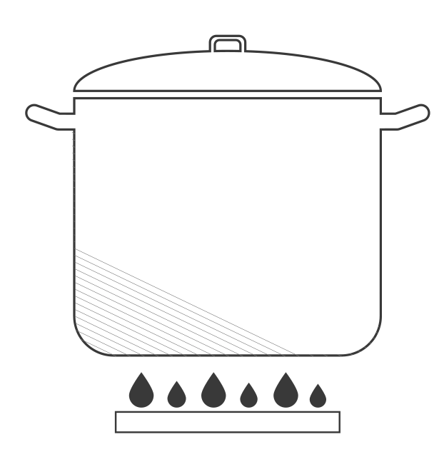
* 4. Get acquainted with the pronunciation of standard English

## What About Listening?

Listening is an important receptive skill. It is a good source for learning spoken English. It is also a good way of developing vocabulary and pronunciation. There are strategies you can follow when you watch or listen to a program in English.

* Listen at least 3 times. Before listening, be prepared and try to anticipate the content.
* The first time you listen, do it without stopping and try to concentrate on the general meaning of the program.
* The second time, listen and try to answer basic questions such as “who?” “what?” “where?” “when?” “how?” “why?”. You can also make a note of key words.
* The third time, listen and check with the transcript.

Here are some tips:

* Try to listen to native speakers and pay attention to the way they speak.
* Listen to yourself or even record yourself and compare what you say to other people.
* Listen for fun! Listen to songs in English, watch movies or TV series.
* Listen or watch several times the same program. This serves as drill and will help you learn unconsciously.



## Vocabulary: Learning Strategies (1/2)

Choose your favorite way of recording vocabulary among these different options:

Word bubbles/spider maps:

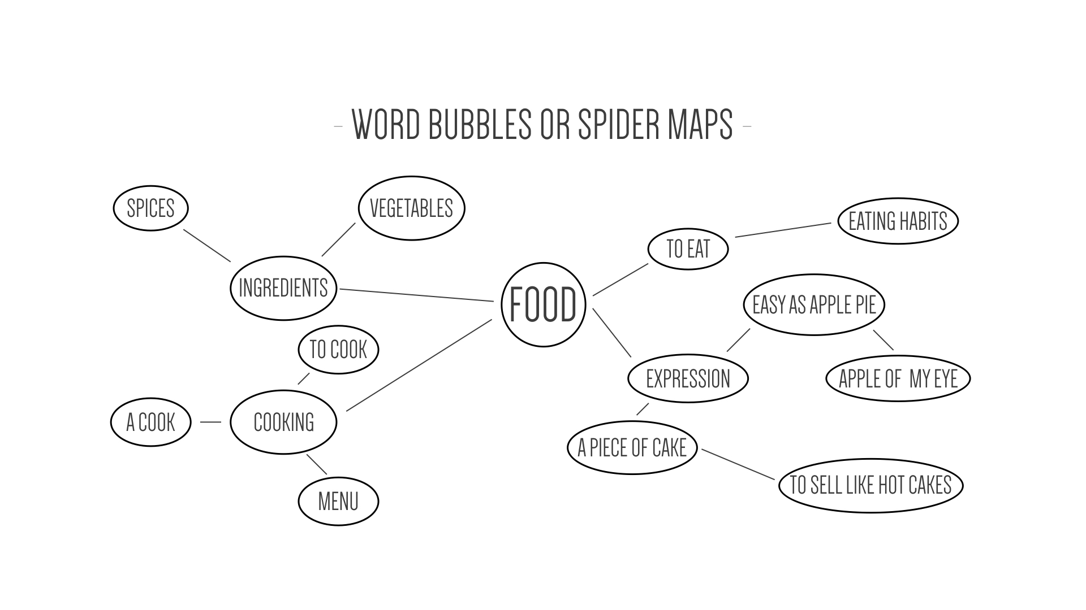

Word forks:

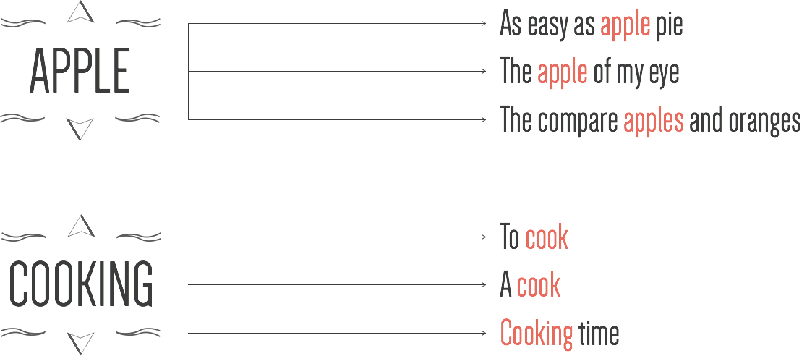

Flashcards/stickers:

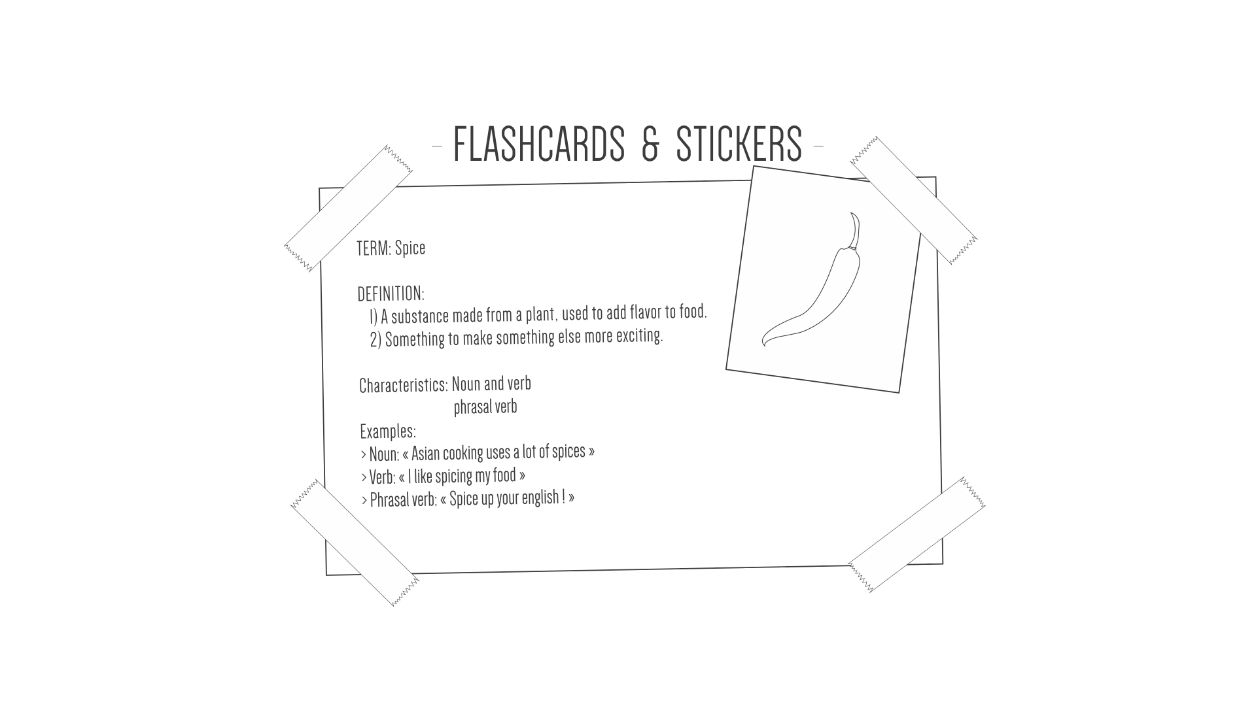

Plan your vocabulary learning:

How many words do I want to learn? ……………………………………………………

Where do I learn them? ………………………………………………………………………

When do I learn them? ………………………………………………………………………

How often do I revise them? ………………………………………………………………

1. **Grammar Bites: The Basics**

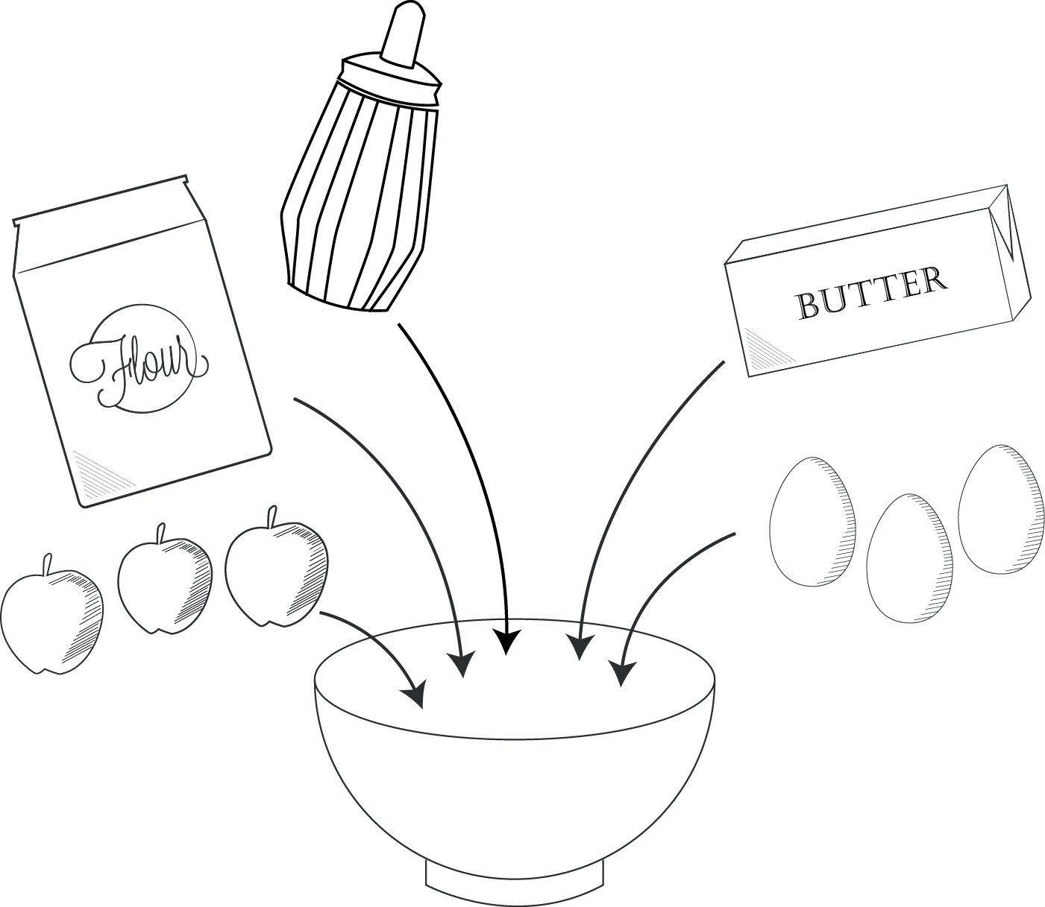

Cooking = how to combine ingredients to prepare a meal.

Grammar = how to combine words to give a message.

A basic recipe tells you in which order you add your ingredients.

Grammar helps you know in which order you put words.

The basic sentence structure in English is:

|  |  |  |
| --- | --- | --- |
| SUBJECT | VERB | COMPLEMENT |

Examples:

* I like cooking (subject + verb + another verb)
* I like apples (subject + verb + noun)
* I want to learn English (subject + verb + specific structure)

***Exercise***: Identifying word categories

The category of a word indicates the role it plays in a sentence. Identify the category of each word in the following sentence:

***A good learner knows his or her learning style and he or she works regularly on the MOOC.***

## Pronunciation: Standard English

The tables below are phonetic charts. They contain all the sounds of English and French. What are the differences?

|  |
| --- |
| **ENGLISH** |
| Macintosh HD:Users:Ariane:Desktop:M3-4.5:M3-4.5.002.jpeg |
| **FRENCH** |
| Macintosh HD:Users:Ariane:Desktop:M3-4.5.1-How to Learn Sounds - copie:M3-4.5.1-How to Learn Sounds - copie.004.jpeg |

# Macintosh HD:Users:Ariane:Downloads:picto-ok:mange.pngModule 3: A Taste for Learning

* On the Menu:
* 1. To develop reading strategies
* 2. To develop vocabulary learning strategies (2/2)
* 3. Grammar bites: master the use of pronouns and determiners, be able to form questions and negations
* 4. To identify the different sounds of English: the vowels

## What About Reading?

Complete the following notes:

There are 3 stepsto follow when you read a text:

Step 1: …………………………………

Before reading your text, you can anticipate the content with the title and the introduction. If you know the theme, the subject of the text, you are better prepared. You can **make guesses**.

Step 2: …………………………………

Read the text a first time. Read the text without stopping **even if** you don’t understand everything. Ask yourself simple questions like: who, what, where, when, why, how? Remember that I also gave you these simple questions when you learned listening strategies. It is the same principle here and not all the questions have an answer each time.

Step 3: …………………………………

Be active: use pens, colors, paper, cards, and your notebook. Use colors to **underline** or highlight words or expressions that are difficult to understand, to **circle** the characters, or the **logical connectors**, the words that create the links between the different ideas.

In module 5, we are going to study the structure of a text **in detail**. I can already tell you that a text **contains** paragraphs and each paragraph has **one main idea**. Very often, the first sentence corresponds to that main idea. These elements are really helpful when reading a long and complicated text.

Ask yourself how new information **relates** **to** the information before. Look at the examples and illustrations and try to **predict** what is coming next in the text.

**How to Improve Reading?**

You can improve your reading skills by … reading. It is as simple as that. Read as much as possible! It may be hard at the beginning but it becomes easier after a certain time.

Pay attention to language structures:

* Word categories such as verbs, adjectives, nouns, pronouns. Go back to module 2 to revise word categories if necessary.
* The structure of the sentence: where is my subject, where is my verb, where is the complement (a complement is also called "object")?
* The chain of ideas: what are the links between the ideas? Is it a cause, a consequence, a contrast or an example?

Always **search for** coherence**.** The text has, of course, a message **to deliver**! At the end of this module, you will find a checklist to help you see if you use the right strategies when reading a text.

## Vocabulary Learning Strategies (2/2)

***Knowing a Word***

Knowing a word is more than just knowing its translationinto French or into English.

You also need to know:

* Spelling: the way we write the word.
* Meaning in English: the definition in English or a synonym, antonym if possible. You also need to know the context in which you can use the word. Always write down a sentence in which the word is used. This will help you remember the meaning more easily.
* Pronunciation: with the IPA, you know automatically how to pronounce a word.
* Grammar information about the word: word category, combination with other words “collocations”, particular structure (for verbs, the use of a preposition).
* Register: informal, neutral or formal. According to the situation, you have to adapt your language.

***Guessing the Meaning of a Word***

When reading and listening, ask yourself this question: “Do I really need to know this word to understand the general meaning of my text or video?” If the answer is no, you can continue reading. If the answer is yes, you can ask yourself a second question: “Can I guess its meaning?” The answer is, of course, yes. You can always try to guess. You should look at several elements:

* What is the category: is the word a verb, a noun or an adjective?
* What are the words around it: Is it, for example, an adjective before a noun?
* Is it similar to a word in my own language? Remember that there are a lot of cognates but pay attention to false friends.
* What is the origin or the root of the word?

There are times when you will really need to know the meaning of the word. That is when you use dictionaries.

## Grammar Bites

### Pronouns and determiners

|  |  |  |  |
| --- | --- | --- | --- |
| **Pronouns** | | | |
| **Subject** | **Object** | **Reflexive** | **Possessive** |
| I | Me | Myself | Mine |
| You | You | Yourself | Yours |
| He | Him | Himself | His |
| She | Her | Herself | Hers |
| It | It | Itself | Its |
| We | Us | Ourselves | Ours |
| You | You | Yourselves | Yours |
| They | Them | Themselves | Theirs |

|  |  |
| --- | --- |
| **Determiners** | |
| Articles (indefinite & definite) | a / an / the |
| Demonstratives | this / that / these / those |
| Possessives | my / your / his / her / its / our / your / their |

***The Importance of Verbs***

When you learn English grammar, verbs play an important role. They are an essential part of the sentence because they express action. Compare the following examples:

|  |  |
| --- | --- |
| French | English |
| *Cette politique implique une amélioration de l’enseignement supérieur et le développement de la recherche scientifique.*  In this sentence, there are 2 nouns to express the main ideas: “amélioration” and “développement”. | *This policy implies improving higher education and developing scientific research.*  We don’t use nouns but verbs. This is really typical of the English language; we always prefer to use verbs instead of nouns. |

In English, there are 3 types of verbs:

* There are normal verbs like “to live”, “to like”, to eat”.
* There are auxiliary verbs, verbs that help other verbs like “to do”, “to have” and “to be”. “To do” helps to build questions and negations. “To have” helps to build perfect tenses and “to be” helps to build continuous tenses.
* There are modal auxiliary verbs: can, could, may, should, must, … . They help to add a nuance such as possibility, capacity, obligation, advice,…  We will study them in module 8.

### How to Form Tenses

3 basic formulas to form tenses:

* **TO BE + -ING**

TO BE as an auxiliary + verb in -ING to form CONTINUOUS tenses

* **TO HAVE + Past Participle**

TO HAVE as an auxiliary + the past participle of a verb to form PERFECT tenses

* **TO BE + Past Participle**

TO BE as an auxiliary + the past participle of a verb to form the PASSIVE voice

|  |  |  |  |
| --- | --- | --- | --- |
| **ACTIVE VOICE**  ***The subject does the action*** | **SIMPLE** | **CONTINUOUS** | **PERFECT**  **SIMPLE** |
| **PRESENT** | Infinitive without TO  *I play*  *He plays* | TO BE (in present)  + verb in –ING  *I am playing*  *He is playing* | TO HAVE (in present)  + Past Participle  *I have played*  *He has played* |
| **PAST** | + ED  + Irregular verbs  *I played*  *He played* | TO BE (in past)  + verb in –ING  *I was playing*  *He was playing* | TO HAVE (in past)  + Past Participle  *I had played*  *He had played* |

### How to Form Questions & Negations

|  |  |  |  |  |
| --- | --- | --- | --- | --- |
| **ACTIVE VOICE**  ***The subject does the action*** | | **SIMPLE** | **CONTINUOUS** | **PERFECT SIMPLE** |
| **PRESENT** | QUESTIONS | DO + INVERSION  *Do I play?*  *Does he play?* | TO BE (in present)  + verb in -ING  Inversion subject-auxiliary TO BE  *Am I playing?*  *Are you playing?*  *Is he playing?* | TO HAVE (in present)  + Past Participle  Inversion subject-auxiliary TO HAVE  *Have I played?*  *Has he played?* |
| NEGATIONS | DO + NOT  *I do not play*  *He does not play or*  *He doesn’t play* | TO BE + NOT  *I am not playing or I’m not playing*  *He isn’t playing* | TO HAVE + NOT  *I haven’t played*  *He has not played* |
| **PAST** | QUESTIONS | DID + Inversion  *Did I play?*  *Did he play?* | TO BE (in past) +  verb in -ING  Inversion subject-auxiliary TO BE  *Was I playing?*  *Was he playing?* | TO HAVE (in past)  + Past Participle  Inversion subject-auxiliary TO HAVE  *Had I played?*  *Had he played?* |
| NEGATIONS | DID + NOT  *I did not play*  *He didn’t play* | TO BE + NOT  *I was not playing*  *He wasn’t playing* | TO HAVE + NOT  *I hadn’t played*  *He had not played* |

**Exercise**

Invent questions for these answers:

1. ……………………………………………………………………………….…? I go to classes twice a week.
2. …………………………………………………………………………………………...? I work alone at home.
3. ………………………………………………………………………….…? I like working with other people.
4. …………………………………………………………………..……? I revise vocabulary every two days.
5. ……………………………………………………………………………..…? I study for 3 hours per week.
6. ……………………………………………………………………………..…? I read fiction and magazines.
7. ……………………………………………………………………………? I study 50 new words per week.
8. …………………………………………………………………………………………….? I watch TV at night.

## Pronunciation: The Vowel Sounds

In English, there is no logical link between spelling and pronunciation. A letter can be pronounced in many different ways.

You will find in the table below the most common pronunciations of vowels. If you are not sure, always check the pronunciation in a dictionary. Fill in the correct phonetic transcription of the sound using the phonetic chart from Module 2 or any website that you find useful. Add more examples if you want.

|  |  |  |
| --- | --- | --- |
| Spelling | Sound | Examples |
| a | … | bag, cat, apple |
| a + consonant + e | … | take, game, late (BUT pay attention to the ending –ATE) |
| a | … | about, ago |
| a | … | walk, talk, also |
| ai | … | train, main, daily |
| air | … | hair, air |
| ar | … | start, bar, part |
| ay | … | say, May, day |
| au | … | taught, cause |
| aw | … | saw |
| all | … | ball, tall, call |
| e | … | pen, end, blend, |
| e | … | me, he, she |
| e + consonant + e | … | these |
| e | … | happen, taken |
| e | … | England |
| ea | … | tea, read, sea, teach |
| ea | … | bread, threat |
| ea | … | great |
| ear | … | hear, beard, real, dear |
| ear | … | learn, early |
| ear | … | wear, bear |
| ee | … | see, cheese |
| eer | … | beer, deer |
| ei | … | eight, weight (exception with ‘height’) |
| ey | … | grey |
| ere | … | where |
| ere | … | were |
| ew | … | new, blew |
| i | … | him, it, live (used as a verb) |
| i + consonant + e | … | time, life, like, fire |
| ie | … | piece, achieve |
| ie | … | pie |
| ie | … | friend |
| ir | … | first, girl, bird |
| o | … | hot, dog, boss |
| o | … | no, go |
| o | … | do, movie |
| o + consonant + e | … | those, nose, bone |
| oa | … | boat, road, goal |
| oi | … | point, join |
| oo | … | food, fool |
| oo | … | foot |
| oo | … | flood, blood |
| oor | … | floor, door |
| or | … | story, more |
| or | … | work, world, word |
| ou | … | sound, found |
| ou | … | you, group |
| ou | … | could, should, would |
| ou | … | young, country |
| ough | … | thought, fought, bought |
| ough | … | through |
| ough | … | although, though |
| ough | … | tough, enough, rough |
| our | … | hour, our, flour |
| our | … | four, your |
| ow | … | blow, know, flow |
| ow | … | now, cow, how, brown, power |
| oy | … | enjoy, boy |
| u | … | cup, but, bus |
| u | … | use, f**u**ture, computer |
| u | … | pull, put |
| u | … | business |
| u | … | rule, solution |
| u | … | cult**u**re, fut**u**re, difficult |
| ui | … | building |
| ue | … | blue |
| ue | … | continue, argue |
| ur | … | turn, burn, blur |
| y (semi-vowel) | … | you |
| y | … | try |
| y + consonant + e | … | type |
| y | … | twenty |

# Module 4: Chips and Tips

* On the menu:

1. Develop vocabulary related to the university world and education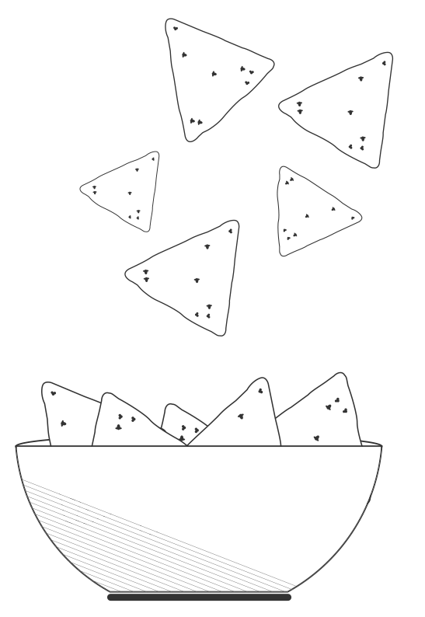 and part 1 of the 1,000 most frequent words.
2. Master the use of present and past tenses (simple and continuous) as well as capitalization and punctuation.
3. Identify the different sounds of English: the consonants
4. Develop reading skills: skimming and scanning
5. Develop oral skills: tips

## Vocabulary: University and Education

Choose your favorite way to study this vocabulary.

## Grammar Bites:

## *Present and Past Tenses*

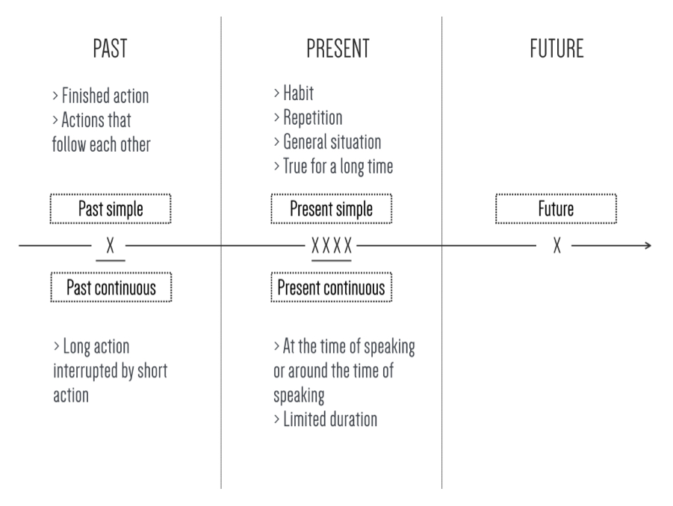

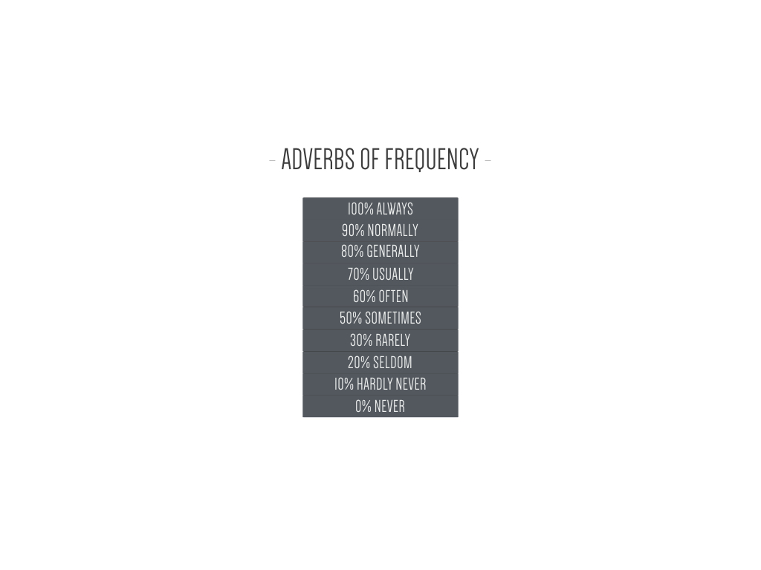

***Punctuation Rules***

Fill in the table with the use of each punctuation symbol:

|  |  |
| --- | --- |
| Punctuation symbol | Use |
| Period . | [Take your notes here] |
| Comma , | [Take your notes here] |
| Semicolon ; | [Take your notes here] |
| Colon : | [Take your notes here] |
| Quotation marks “ ” | [Take your notes here] |
| Brackets | [Take your notes here] |
| Hyphen - | [Take your notes here] |
| Dash – | [Take your notes here] |
| Parentheses ( )  Brackets [ ] | [Take your notes here] |

***Capitalization***

Write down the rules of capitalization:

[Take your notes here]

**Exercise: Indicate where capitalization is missing.**

1. barack obama is the president of the united states of america.
2. the universal declaration of human rights (UDHR) is a declaration that was adopted by the united nations general assembly on 10th december 1948 at the palais de chaillot, in paris.
3. the geneva convention (1929) was signed in geneva in 1929. its official name is the convention relative to the treatment of prisoners of war.
4. “the go-between” is a novel written by l.p. hartley in 1953.
5. the atomium is a building in brussels originally constructed for expo 58, the 1958 brussels world fair.

## Pronunciation: the Consonant Sounds

## You will find in the table below most common pronunciations of consonants. If you are not sure, always check the pronunciation of words in a dictionary. Fill in the correct transcription of the sound using the phonetic chart from Module 2 or any website that you find useful. Add more examples if you want.

|  |  |  |
| --- | --- | --- |
| Spelling | Sound | Examples |
| b | … | best, be |
| c | … | car, can |
| c + e/i/y | … | cent, cinema, society, cycle |
| c + consonant + e | … | nice, dice |
| ch | … | check |
| ck | … | black |
| d | … | do |
| f | … | fly |
| g | … | get, go |
| g | … | general, gin |
| gu | … | guest, guess |
| gu | … | language |
| h | … | hat, hit |
| j | … | July, just |
| k | … | key |
| l | … | life |
| m | … | my, may |
| n | … | no |
| n + c/k | … | uncle, bank |
| ng | … | song, sing |
| ng | … | single |
| p | … | pen |
| ph | … | photo |
| qu | … | quite, quiet |
| r | … | red, right |
| s | … | see |
| s | … | easy |
| sh | … | shoe |
| t | … | ten |
| t | … | nation |
| t | … | picture, future |
| tch | … | catch |
| th | … | three, think |
| th | … | mother |
| v | … | never |
| w | … | well, wild |
| wh | … | white, what |
| wh | … | who, whole |
| x | … | six |
| z | … | zoo |

**Silent Letters**

Pay attention to some consonants that are sometimes not pronounced:

|  |  |
| --- | --- |
| Silent letter | Examples |
| b | climb, dumb |
| d | Wednesday |
| g | foreign, sign |
| gh | eight, high, fight, daughter |
| h | hour, honest, hono(u)r |
| k | knee, know, knowledge |
| l | could, half, walk, would |
| p | psychology |
| s | island |
| t | Christmas, listen |
| w | answer, two, write |

## Reading Skills: Skimming and Scanning

What is skimming?

[Take your notes here]

What is scanning?

[Take your notes here]

## Tips for Improving Oral Skills

Choose 3 tips you find useful:

1. [Take your notes here]

2.

3.

# Module 5: A Piece of CakeMacintosh HD:Users:Ariane:Downloads:picto-ok:cake.png

* On the menu:

1. Raise awareness of idioms and collocations and part 2 of the 1,000 most frequent words
2. Master the use of the present perfect and prepositions of place and time
3. Identify the different sounds of English: the diphthongs
4. Understand the structure of a text
5. **Vocabulary**

What are collocations?

[Take your notes here]

Make or do?

Fill in the table with the expressions you have learned in the MOOC. Add other examples.

|  |  |
| --- | --- |
| MAKE | DO |
| [Take your notes here] | [Take your notes here] |

What are idioms?

Definition: [Take your notes here]

My examples:

1. **Grammar Bites:**

***The present Perfect***

Fill in this timeline with the use of the present perfect:

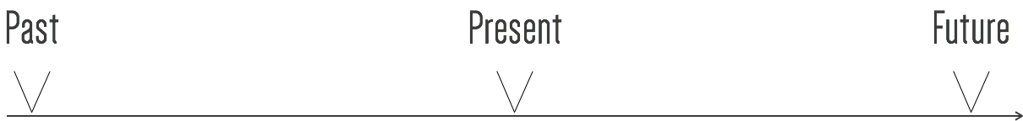

***Prepositions of Place***

Using the box and the muffin from the video, make a note of the use of prepositions of place:

|  |  |  |  |  |  |  |
| --- | --- | --- | --- | --- | --- | --- |
| in | on | at | from | to | above | under |
| near/by | between | against | behind | in front of | opposite |  |





***Prepositions of Time***

|  |  |
| --- | --- |
| Preposition | Use and examples |
| AT | [Take your notes here] |
| IN | [Take your notes here] |
| ON | [Take your notes here] |
| No preposition | [Take your notes here] |
| UNTIL | [Take your notes here] |
| FROM … TO | [Take your notes here] |
| FOR | [Take your notes here] |
| DURING | [Take your notes here] |
| WHILE (=conjunction) | [Take your notes here] |

## The Sounds of English: The Diphthongs

Make a note of the diphthongs that are difficult for you:

[Take your notes here]

## Understand the Structure of a Text

What is a paragraph?

[Take your notes here]

What does a paragraph contain?

|  |  |  |
| --- | --- | --- |
|  |  | [Take your notes here] |
|  | [Take your notes here] |
|  | [Take your notes here] |

**Exercise 1**

In the following topic sentences, indicate where the topic is as well as the controlling idea.

1. There are many reasons why pollution in Mexico City is one of the **worst** in the world.

2. To be an **effective** President requires certain characteristics.

3. There are many possible contributing factors to **global warming**.

4. Students **meet** many difficulties when they first start university.

5. Dogs make wonderful **pets** because they help you to live longer.

6. Crime in **poor areas** takes place as a result of a systemic discrimination.

7. **Teen** **pregnancy** may be **prevented** by improved sex education.

8. Cooking requires a great number of different skills.

9. It is important to be prepared before starting the exam period.

10. **Graduating from** secondary school is important for many different reasons.

**Exercise 2**

In the following paragraph, highlight the topic sentence, the concluding sentence and the supporting details.

My name is Nelson Mandela, and I have had an **unusual** life: I have been both a prisoner and the president of my country. I was born in 1918 in a small village in South Africa. My father, Henry Mandela, was the chief of our tribe. As a child, I **took care of** the family’s **cattle** and **goats**. When I **grew up**, I decided to become a **lawyer**. This seemed to be a good way to help my people. After I became a lawyer, I became the leader of a group of young Africans who wanted to change the system of discrimination in my country. **Due to** my political activities, I went to prison for twenty-seven years. The prison was in a cold, deserted **island** in the Atlantic Ocean. However, the world didn’t forget about me and I received important visitors, **awards**, and university **degrees** from all over the world. I also learned Afrikaans, which is the language of white South Africans. Of course, I also speak English and Xhosa, which is the language of my tribe. In 1990, I was **set free**. I became the President of South Africa in 1994. During my time **in office**, I tried to bring peace, democracy, and prosperity to all of my country’s people.

# Module 6: My Cup of Tea Macintosh HD:Users:Ariane:Downloads:picto-ok:the.png

On the menu:

1. Record word families and part 3 of the 1,000 most frequent words
2. Master the use of future time and conditional structures
3. Identify the common mistakes by French speakers and make the distinction between British and American English
4. Understand the coherence of a text: connectors
5. **Vocabulary**

What are word families and why are they important?

[Take your notes here]

1. **Grammar Bites**

***Future Time:***

|  |  |
| --- | --- |
| WILL | GOING TO |
| Prediction  [Take your notes here]  Decision | Prediction  [Take your notes here]  Decision |
| Present simple | **Present continuous** |
| Official dates  [Take your notes here] | Planned arrangement in diary  [Take your notes here] |

***Conditional Structures:***

|  |  |
| --- | --- |
| Type | Examples |
| Conditional 1  If + present simple + WILL  or  If + present simple + present simple | [Take your notes here] |
| Conditional 2  If + past simple + WOULD | [Take your notes here] |

1. **Pronunciation: Common Mistakes by French Speakers**

Fill in the table with some examples given in the video:

|  |  |
| --- | --- |
| Common Mistakes | Examples |
| Vowels   * Short vs. long vowels * Tendency to produce vowels in unstressed syllables as they are written | [Take your notes here] |
| Consonants | [Take your notes here] |
| Others   * Tendency to produce strong forms where we use weak forms * Tendency to place word stress on later syllables where normally the stress is on the first syllable * Problems with past participles | [Take your notes here] |

|  |  |
| --- | --- |
| Use | Examples of connector |
| To add a similar idea | [Take your notes here] |
| To add contrast | [Take your notes here] |
| To define time | [Take your notes here] |
| To give a reason | [Take your notes here] |
| To add an opposite idea | [Take your notes here] |
| To explain or reformulate | [Take your notes here] |
| To reinforce an idea | [Take your notes here] |
| To give another possibility | [Take your notes here] |
| To give an example | [Take your notes here] |
| To conclude | [Take your notes here] |

1. **Skills: Connectors and Transition Signals**

Fill in the table with examples of connectors:

# Macintosh HD:Users:Ariane:Downloads:picto-ok:four.pngModule 7: Cooked to Perfection

* On the menu:

1. Vocabulary: Part 4 of the list of the 1,000 most frequent words
2. Master the use of relative clauses
3. Raising awareness of word stress
4. Make simple notes
5. **Vocabulary:** cf. list
6. **Grammar Bites: Relative Clauses**

|  |  |  |
| --- | --- | --- |
|  | People | Things |
| SUBJECT | who | that |
| OBJECT | that /Macintosh HD:Users:Ariane:Desktop:Capture d’écran 2016-10-06 à 12.03.01.png | that /Macintosh HD:Users:Ariane:Desktop:Capture d’écran 2016-10-06 à 12.03.01.png |
| POSSESSIVE | whose | whose |
| PLACE | _ | where |
| TIME | _ | when |
| OBJECT + PREPOSITION | that / Macintosh HD:Users:Ariane:Desktop:Capture d’écran 2016-10-06 à 12.03.01.png | that /Macintosh HD:Users:Ariane:Desktop:Capture d’écran 2016-10-06 à 12.03.01.png |

1. **Pronunciation: Word Stress**

What is stress and why is it important?

|  |  |
| --- | --- |
| English | French |
| Stress-timed  One syllable is more important  [Take your notes here] | Syllable-timed  Same weight for each syllable  [Take your notes here] |

What is elision?

[Take your notes here]

1. **Skills: Make Simple Notes**

Watch the video and make notes about how to make notes then compare with the key provided after the video.

[Take your notes here]

# Module 8: You Are a Big Cheese

On the menu:

1. Get acquainted with the vocabulary used in academic texts
2. Master the use of modal auxiliaries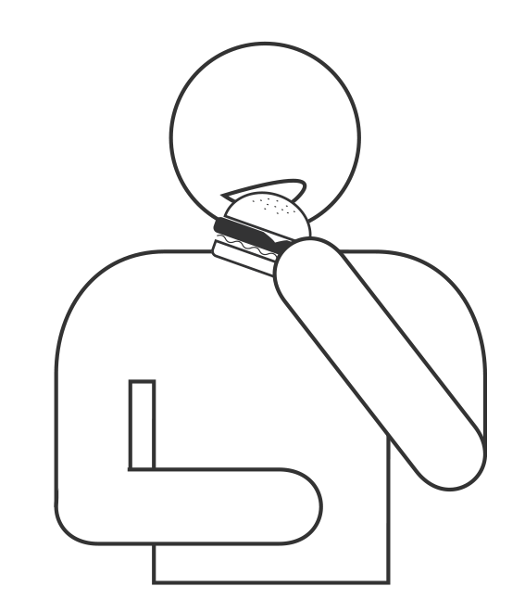
3. Raise awareness of minimal pairs
4. Get acquainted with writing a short paragraph
5. **Academic Vocabulary**

What is academic language and why is it important?

[Take your notes here]

**Exercise:**

Read the two passages below and make up a list of differences between academic and informal English in the "Activity" section in your notebook.

|  |  |
| --- | --- |
| Text A Formal Language | Text B Informal Language |
| The inequity in the distribution of wealth in Australia is yet another indicator of Australia's lack of egalitarianism. In 1995, 20% of the Australian population owned 72.2% of Australia's wealth with the top 50% owning 92.1% (Raskall, 1998: 287). Such a significant skew in the distribution of wealth indicates that, at least in terms of economics, there is an established class system in Australia. McGregor (1988) argues that Australian society can be categorised into three levels: the Upper, Middle and Working classes. In addition, it has been shown that most Australians continue to remain in the class into which they were born (McGregor, 1988: 156) despite arguments about the ease of social mobility in Australian society (Fitzpatrick, 1994). The issue of class and its inherent inequity, however, is further compounded by factors such as race and gender within and across these class divisions. | Because only a few people have most of the money and power in Australia, I conclude that it is not an equal society. Society has an Upper, Middle and Lower class and I think that most people when they are born into one class, end up staying in that class for their whole lives. When all three classes are looked at more closely, other things such as the differences between the sexes and people's racial backgrounds also add to the unequal nature of Australian society. |

1. **Grammar Bites: Modal Auxiliaries**

Fill in the table below with examples for each use:

|  |  |
| --- | --- |
| Modal | Use and examples |
| can  could | possibility, ability, permission, offer/request  more polite + past ability |
| may | probability, permission |
| should | advisability |
| must/mustn’t  have to | obligation from speaker/prohibition  obligation from someone else + past/future |
| must/can’t | Logical deduction |
| don’t have to = don’t need to | Absence of obligation |

1. **Pronunciation: Minimal Pairs**

What are minimal pairs?

[Take your notes here]

Examples:

* reach/rich
* man/main

Add more examples to practice on a regular basis.

1. **Skills: Writing a Short Paragraph**

What are the four steps when you write a text?

1. [Take your notes here]

2.

3.

4.

# Macintosh HD:Users:Ariane:Downloads:picto-ok:gateau.pngModule 9: The Icing on the Cake

* On the Menu:

1. Let’s eat the cake
2. Online tools for lifelong learning
3. **Let’s Eat the Cake!**

In the box below, write down your impressions about your learning experience with this MOOC.

[Take your notes here]

1. **Online Tools for Lifelong Learning**

In the box below, make a note of the resources that you will continue to use after the MOOC.

[Take your notes here]

